**Table Structures**

**Employees Table**

* employee_id (Primary Key)
* first_name
* last_name
* email
* phone_number
* hire_date
* job_id
* salary
* commission_pct
* manager_id
* department_id (Foreign Key to departments table)

**Departments Table**

* department_id (Primary Key)
* department_name
* manager_id
* location_id

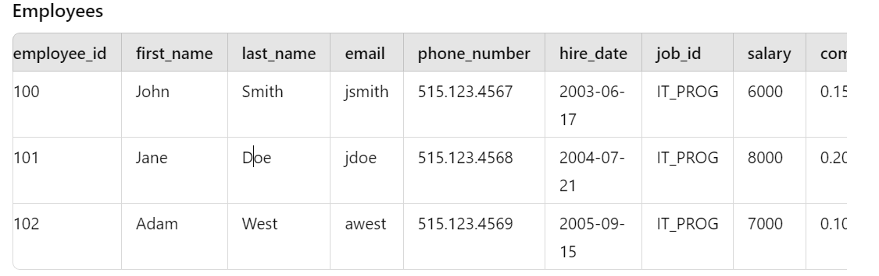

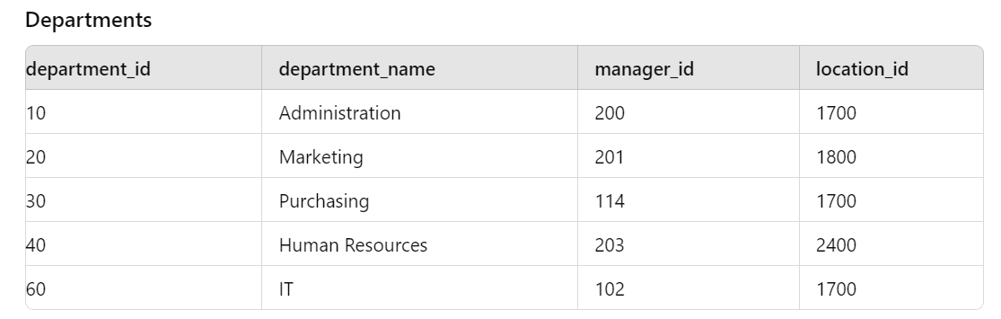

* Select all employees
* Select the first name and salary of employees who work in the 'IT' department:
* Find the total salary paid to employees in each department
* Find the average salary of employees who have a commission percentage greater than 0:
* List the names of managers along with the names of the employees they manage
* Find the highest salary in each department
* Select employees who were hired in the year 2005
* Find the department names that have more than 2 employees
* Select the details of employees who do not have a manager
* List the department name and the number of employees in each department, sorted by the number of employees in descending order